FOUNDATIONS OF PROGRAMMING
ASSIGNMENTS
Assignment – 01:
Problem Statement:
Write a program in C to check whether a given year is a Leap Year
Code:
#include <stdio.h>
int main()
{
int year;
printf("Enter a year: ");
scanf("%d",&year);
if ((year%4==0&&year%100!=0)||(year%400==0))
{
printf("%d is a Leap Year.\n",year);
}
else
{
printf("%d is not a Leap Year.\n",year);
}
}

Input & Output:
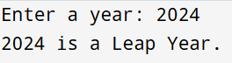
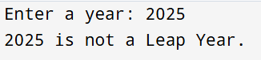
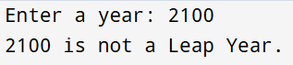

Assignment – 02:
Problem Statement:
Write a menu driven program in C to implement the basic arithmetic operations such as Addition, Subtraction, Multiplication, and Division.
Code:
#include <stdio.h>
int main()
{
char op;
float num1,num2,result;
int rem;
printf("Calculator operations are:\n");
printf("+ for addition\n");
printf("- for subtraction\n");
printf("* for multipliclation\n");
printf("/ for division\n");
printf("m for modulus\n");
printf("Enter an operator: ");
scanf("%c",&op);
printf("Enter two numbers: ");
scanf("%f%f",&num1,&num2);
switch(op)
{
case '+': result=num1+num2;
printf("The sum is: %f",result);
break;
case '-': result=num1-num2;
printf("The difference is: %f",result);
break;
case '*': result=num1*num2;
printf("The product is: %f",result);
break;
case '/': if (num2!=0)
{
result=num1/num2;
printf("The quotient is: %f",result);
}
else
{
printf("Error! Division by zero is not defined");
}
break;
case 'm': rem=(int)num1%(int)num2;
printf("The reamainder is: %d",rem);
break;
default: printf("Sorry, this operator is not defined!");
break;
}
}
Input & Output:
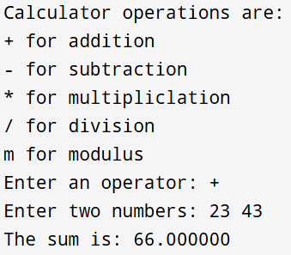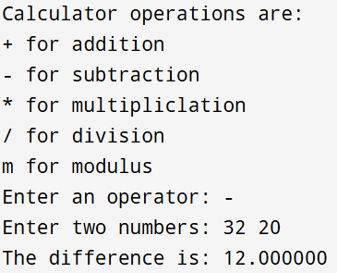
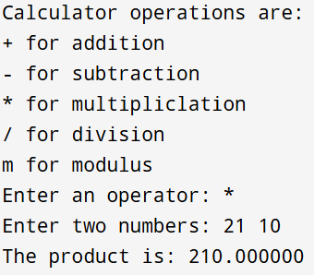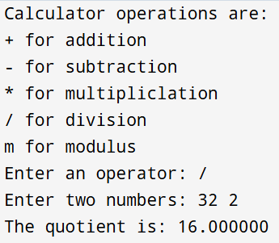

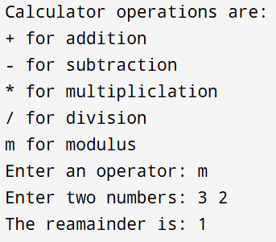

Assignment – 03:
Problem Statement:
Write a program in C to generate multiplication tables for a given number.
Code:
#include <stdio.h>
int main()
{
int num,i=1;
printf("Enter a number: ");
scanf("%d",&num);
printf("The multiplication table (upto 10) of %d is: \n",num);
while (i<=10)
{
printf("%d*%d = %d\n",i,num,num*i);
i++;
}
}
Input & Output:
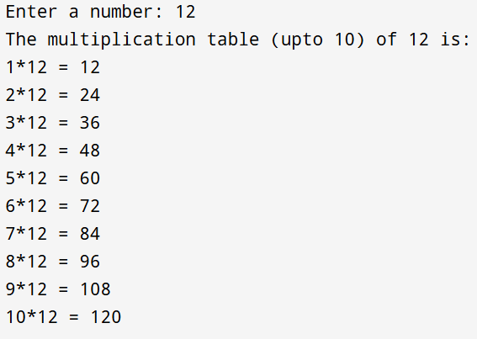
Assignment – 04:
Problem Statement:
Write a C Program to calculate the salary of an employee given his basic pay (taken as input from the user). Calculate gross salary of employee. Let HRA be 10 % of basic pay and TA be 5% of basic pay. Let employees pay professional tax as 2% of total salary. Calculate net salary payable after deductions.
Code:
#include <stdio.h>
int main()
{
int bs;
float hra,ta,gs,pt,ns;
printf("Enter the Base Salary of the Employee: ");
scanf("%d",&bs);
hra=0.1*bs;
ta=0.05*bs;
gs=bs+hra+ta;
pt=0.02*gs;
ns=gs-pt;
printf("The Gross Salary of the Employee is: %f\n",gs);
printf("The Net Salary payable after the deductions is: %f",ns);
}
Input & Output:
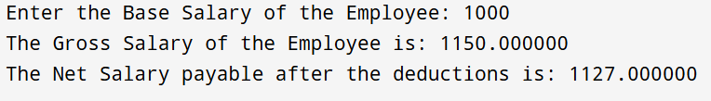

Assignment – 05:
Problem Statement:
Write a program in C to perform basic matrix operations, such as:
1. Addition of two matrices
2. Saddle point of a matrix
3. Inverse of a matrix
4. Magic square of a matrix
Code:
#include <stdio.h>
int main()
{
int A[10][10],B[10][10],C[10][10];
int i,j,r,c,n;
printf("Enter rows and columns: ");
scanf("%d%d",&r,&c);
printf("Enter Matrix A:\n");
for (i=0;i<r;i++)
{
for (j=0;j<c;j++)
{
scanf("%d",&A[i][j]);
}
}
printf("Enter Matrix B:\n");
for (i=0;i<r;i++)
{
for (j=0;j<c;j++)
{
scanf("%d",&B[i][j]);
}
}
printf("Addition:\n");
for (i=0;i<r;i++)
{
for (j=0;j<c;j++)
{
C[i][j]=A[i][j]+B[i][j];
printf("%d ",C[i][j]);
}
printf("\n");
}
int found=0;
for (i=0;i<r;i++)
{
int min=A[i][0],col=0;
for (j=1;j<c;j++)
{
if (A[i][j]<min)
{
min=A[i][j];
col=j;
}
}
int flag=1;
for (int k=0;k<r;k++)
{
if (A[k][col]>min)
{
flag=0;
break;
}
}
if (flag)
{
printf("Saddle Point = %d\n",min);
found=1;
}
}
if (!found)
{
printf("No Saddle Point\n");
}
int M[2][2];
float det;
printf("Enter 2x2 matrix:\n");
for (i=0;i<2;i++)
{
for (j=0;j<2;j++)
{
scanf("%d",&M[i][j]);
}
}
det=M[0][0]*M[1][1]-M[0][1]*M[1][0];
if (det==0)
{
printf("Inverse not possible\n");
}
else
{
printf("Inverse:\n");
printf("%.2f %.2f\n",M[1][1]/det,-M[0][1]/det);
printf("%.2f %.2f\n",-M[1][0]/det,M[0][0]/det);
}
int sum=0,temp;
printf("Enter order of square matrix: ");
scanf("%d",&n);
printf("Enter matrix:\n");
for(i=0;i<n;i++)
{
for(j=0;j<n;j++)
{
scanf("%d",&A[i][j]);
}
}
for(j=0;j<n;j++)
{
sum+=A[0][j];
}
for(i=0;i<n;i++)
{
temp=0;
for(j=0;j<n;j++)
{
temp+=A[i][j];
}
if(temp!=sum)
{
printf("Not Magic Square\n");
return 0;
}
}
for(j=0;j<n;j++)
{
temp=0;
for(i=0;i<n;i++)
{
temp+=A[i][j];
}
if(temp!=sum)
{
printf("Not Magic Square\n");
return 0;
}
}
temp=0;
for(i=0;i<n;i++)
{
temp+=A[i][i];
}
if(temp!=sum)
{
printf("Not Magic Square\n");
return 0;
}
temp=0;
for(i=0;i<n;i++)
{
temp+=A[i][n-i-1];
}
if(temp!=sum)
{
printf("Not Magic Square\n");
return 0;
}
printf("Magic Square\n");
return 0;
}
Input & Output:
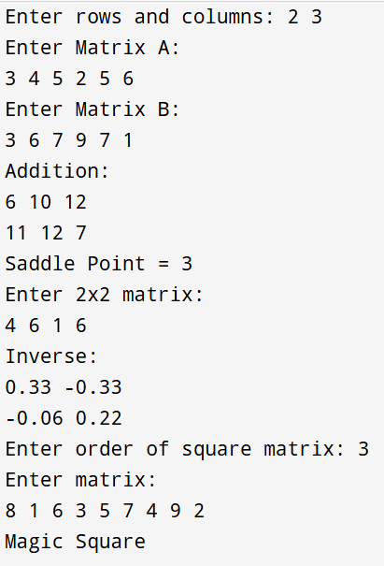

Assignment – 06:
Problem Statement:
Write a C function to compute the factorial of a number with and without recursion.
Code:
#include <stdio.h>
int fact_iterative (int n)
{
int fact=1;
for (int i=1;i<=n;i++)
{
fact=fact*i;
}
return fact;
}
int fact_recursive (int n)
{
if (n==0||n==1)
{
return 1;
}
else
{
return n*fact_recursive(n-1);
}
}
int main()
{
int num;
printf("Enter a number: ");
scanf("%d",&num);
if (num<0)
{
printf("Factorial not defined for negative numbers\n");
}
else
{
printf("Factorial (Without Recursion) = %d\n",fact_iterative(num));
printf("Factorial (With Recursion) = %d\n",fact_recursive(num));
}
}
Input & Output:
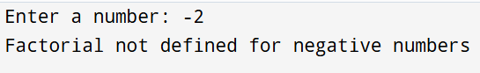
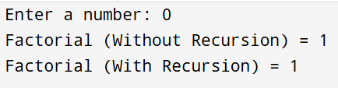
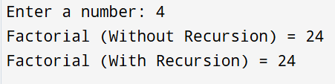

Assignment – 07:
Problem Statement:
Write a C program to accept student details and display their result using an array of structures.
Code:
#include <stdio.h>
struct student
{
int roll;
char name[50];
int m1, m2, m3;
int total;
float avg;
}s[10];
int main()
{
int n, i;
printf("Enter number of students: ");
scanf("%d", &n);
for(i = 0; i < n; i++)
{
printf("\nEnter details of student %d\n", i+1);
printf("Roll No: ");
scanf("%d", &s[i].roll);
printf("Name: ");
scanf("%s", s[i].name);
printf("Marks in 3 subjects: ");
scanf("%d %d %d", &s[i].m1, &s[i].m2, &s[i].m3);
s[i].total = s[i].m1 + s[i].m2 + s[i].m3;
s[i].avg = s[i].total / 3.0;
}
printf("\n--- Student Results ---\n");
for(i = 0; i < n; i++)
{
printf("\nRoll No: %d", s[i].roll);
printf("\nName: %s", s[i].name);
printf("\nTotal Marks: %d", s[i].total);
printf("\nPercentage: %.2f\n", s[i].avg);
}
}
Input & Output:
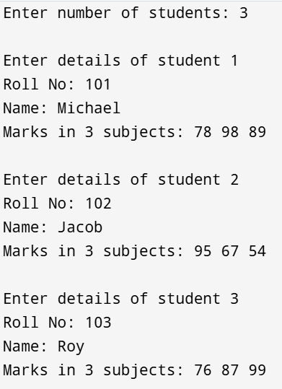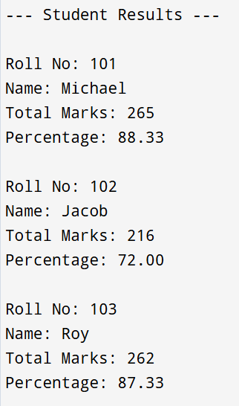

Assignment – 08:
Problem Statement:
Write a program in C to accept marks of five courses of a student and compute the result. A student is considered PASS if he/she scores 40 marks or more in each course. If the student passes, calculate the aggregate percentage and assign the grade as follows:
- Aggregate ≥ 75% : Distinction
- Aggregate ≥ 60% and < 75% : First Division
- Aggregate ≥ 50% and < 60% : Second Division
- Aggregate ≥ 40% and < 50% : Third Division
Code:
#include <stdio.h>
int main()
{
int m1,m2,m3,m4,m5;
float avg;
printf("Enter marks of five subjects: ");
scanf("%d%d%d%d%d",&m1,&m2,&m3,&m4,&m5);
printf("Total Marks: %d\n",m1+m2+m3+m4+m5);
avg=(m1+m2+m3+m4+m5)/5;
printf("Percentage: %f\n",avg);
if (m1>=40&&m2>=40&&m3>=40&&m4>=40&&m5>=40)
{
printf("Result: Pass\n");
if (avg>=75)
{
printf("Grade: Distinction");
}
else if ((avg>=60)&&(avg<75))
{
printf("Grade: First Division");
}
else if ((avg>=50)&&(avg<60))
{
printf("Grade: Second Division");
}
else if ((avg>=40)&&(avg<50))
{
printf("Grade: Third Division");
}
}
else
{
printf("Result: Fail");
}
}
Input & Output:
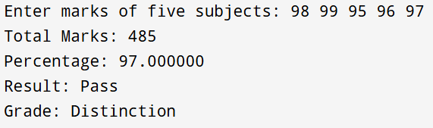
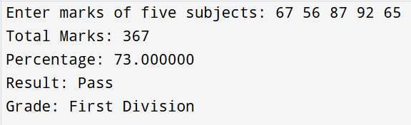
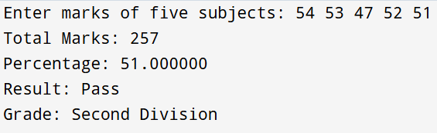
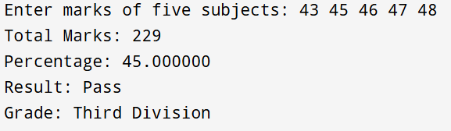
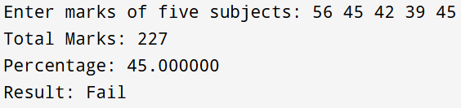

Assignment – 09:
Problem Statement:
Write a program in C to check whether the given number is an Armstrong number or not.
An Armstrong number is an integer with three digits such that the sum of the cubes of its digits is equal to the number itself.
Example: 371
Code:
#include <stdio.h>
int main()
{
int num,temp,digit,sum=0;
printf("Enter a 3-Digit number: ");
scanf("%d",&num);
temp=num;
while (temp!=0)
{
digit=temp%10;
sum=sum+(digit*digit*digit);
temp=temp/10;
}
if (sum==num)
{
printf("%d is an Armstrong Number",num);
}
else
{
printf("%d is not an Armstrong Number",num);
}
}
Input & Output:
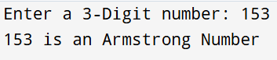
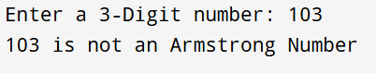
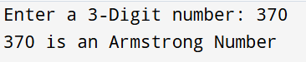

Assignment – 10:
Problem Statement :
Write a program in C to simulate a simple calculator that performs basic arithmetic operations such as addition, subtraction, multiplication, and division. The calculator should also perform special operations like computing xʸ (power) and x! (factorial).
Code:
#include <stdio.h>
int factorial(int n)
{
int fact=1;
for (int i=1;i<=n;i++)
{
fact=fact*i;
}
return fact;
}
int main()
{
int choice,n;
float a,b,result;
printf("Simple Calculator\n");
printf("1. Addition\n");
printf("2. Subtraction\n");
printf("3. Multiplication\n");
printf("4. Division\n");
printf("5. Power (x^y)\n");
printf("6. Factorial (x!)\n");
printf("Enter your choice: ");
scanf("%d",&choice);
switch (choice)
{
case 1: printf("Enter two numbers: ");
scanf("%f%f",&a,&b);
printf("Sum = %.2f\n",a+b);
break;
case 2: printf("Enter two numbers: ");
scanf("%f%f",&a,&b);
printf("Difference = %.2f\n",a-b);
break;
case 3: printf("Enter two numbers: ");
scanf("%f%f",&a,&b);
printf("Product = %.2f\n",a*b);
break;
case 4: printf("Enter two numbers: ");
scanf("%f%f",&a,&b);
if (b!=0)
{
printf("Result = %.2f\n",a/b);
}
else
{
printf("Error! Division by zero.\n");
}
break;
case 5: printf("Enter base and exponent: ");
scanf("%f%f",&a,&b);
result=1;
for (int i=1;i<=(int)b;i++)
{
result=result*a;
}
printf("Result = %.2f\n",result);
break;
case 6: printf("Enter a number: ");
scanf("%d",&n);
if (n>=0)
{
printf("Factorial = %d\n",factorial(n));
}
else
{
printf("Factorial is not defined for negative numbers.\n");
}
break;
default: printf("Invalid Choice!\n");

}
}
Input & Output:
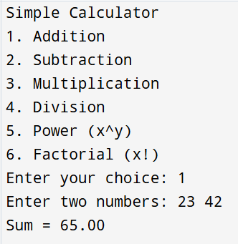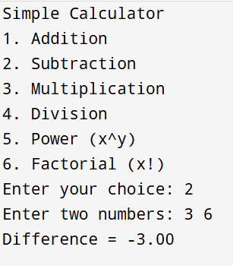
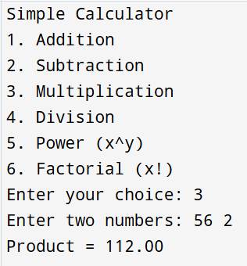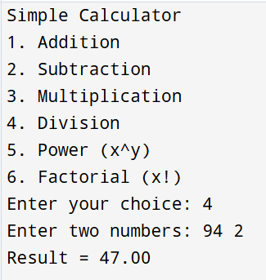
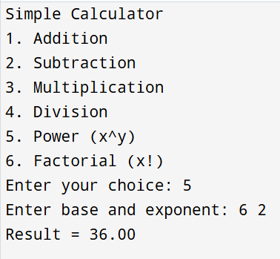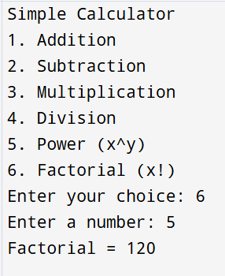

Assignment – 11:
Problem Statement:
Write a program in C to accept a number from the user and compute the following:
- Square root of the number
- Square of the number
- Cube of the number
- Check whether the number is prime
- Factorial of the number
- Prime factors of the number
Code:
#include <stdio.h>
#include <math.h>
int isPrime (int n)
{
if (n<=1)
{
return 0;
}
for (int i=2;i<=n/2;i++)
{
if (n%i==0)
{
return 0;
}
}
return 1;
}
long long factorial (int n)
{
long long fact=1;
for (int i=1;i<=n;i++)
{
fact=fact*i;
}
return fact;
}
void primeFactors (int n)
{
printf ("Prime factors: ");
for (int i=2;i<=n;i++)
{
while (n%i==0)
{
printf("%d ",i);
n=n/i;
}
}
printf("\n");
}
int main()
{
int num;
printf("Enter a number: ");
scanf("%d",&num);
printf("Square Root = %.2f\n",sqrt(num));
printf("Square = %d\n",num*num);
printf("Cube = %d\n",num*num*num);
if (isPrime(num))
{
printf("Number is Prime\n");
}
else
{
printf("Number is not Prime\n");
}
if (num>=0)
{
printf("Factorial = %lld\n",factorial(num));
}
else
{
printf("Factorial not defined for negative numbers\n");
}
if (num>1)
{
primeFactors(num);
}
else
{
printf("No prime factors\n");
}
}

Input & Output:
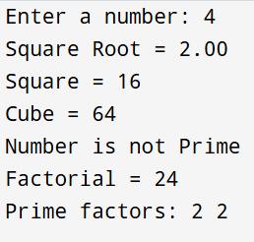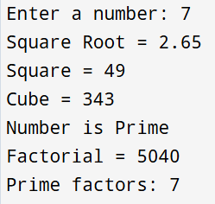

Assignment – 12:
Problem Statement:
Write a program in C to accept two numbers from the user and compute:
- The smallest common divisor of the two numbers (other than 1, if any)
- The Greatest Common Divisor (GCD) of the two numbers
Code:
#include <stdio.h>
int main()
{
int num1, num2, i;
int smallest_divisor = 0;
int gcd;
printf("Enter two numbers: ");
scanf("%d %d", &num1, &num2);
int min;
if (num1<num2)
{
min=num1;
}
else if (num2<num1)
{
min=num2;
}
for (i = 2; i <= min; i++)
{
if (num1 % i == 0 && num2 % i == 0)
{
smallest_divisor = i;
break;
}
}
if (smallest_divisor != 0)
{
printf("Smallest common divisor (other than 1): %d\n", smallest_divisor);
}
else
{
printf("No common divisor other than 1 exists.\n");
}
int a = num1, b = num2, temp ;
while (b!=0)
{
temp=b;
b=a%b;
a=temp;
}
gcd=a;
printf("GCD of the two numbers: %d\n", gcd);
}
Input & Output:
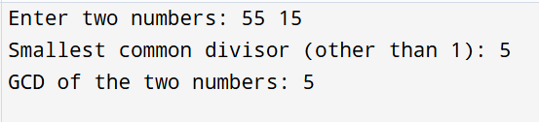
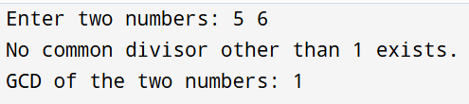
Assignment – 13:
Problem Statement:
Write a program in C to accept a number from the user and print the digits of the number in reverse order.
Code:
#include <stdio.h>
int main()
{
int num,digit;
printf("Enter a number: ");
scanf("%d",&num);
printf("Reversed digits: ");
while(num!=0)
{
digit=num%10;
printf("%d",digit);
num=num/10;
}
}
Input & Output:
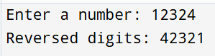
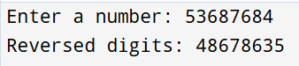

Assignment – 14:
Problem Statement:
Write a C program to input a binary number from the user and convert it into a decimal number.
Code:
#include <stdio.h>
int main()
{
int binary,decimal=0,base=1,digit;
printf("Enter a Binary Number: ");
scanf("%d",&binary);
while (binary!=0)
{
digit=binary%10;
decimal=decimal+digit*base;
binary=binary/10;
base=base*2;
}
printf("Decimal Number = %d\n",decimal);
}
Input & Output:
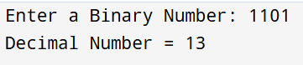
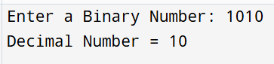
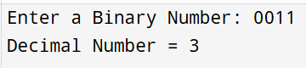
Assignment – 15:
Problem Statement:
Write a C program to generate pseudo random numbers.
Code:
#include <stdio.h>
#include <stdlib.h>
#include <time.h>
int main()
{
int i,n;
printf("Enter the number of random numbers to generate: ");
scanf("%d",&n);
srand(time(0));
printf("Pseudo-random numbers are:\n");
for (i=0;i<n;i++)
{
printf("%d\n",rand() % 900000+100000);
}
}
Input & Output:
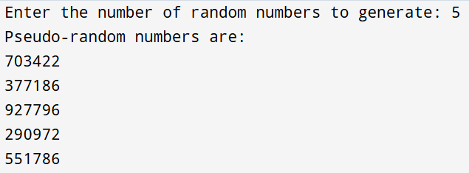
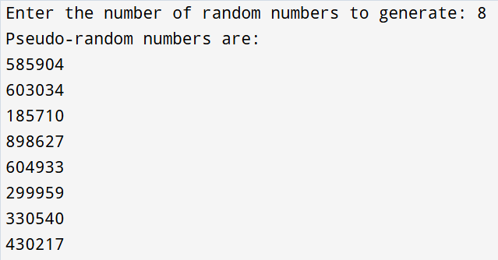

Assignment – 16:
Problem Statement:
To accept a list of N integers and partition the list into two sublists containing even and odd numbers.
Code:
#include <stdio.h>
int main()
{
int n, i;
printf("Enter number of elements: ");
scanf("%d", &n);
int arr[n];
printf("Enter %d integers:\n", n);
for(i = 0; i < n; i++)
{
scanf("%d", &arr[i]);
}
printf("Even numbers:\n");
for(i = 0; i < n; i++)
{
if(arr[i] % 2 == 0)
{
printf("%d ", arr[i]);
}
}
printf("\nOdd numbers:\n");
for(i = 0; i < n; i++)
{
if(arr[i] % 2 != 0)
{
printf("%d ", arr[i]);
}
}
}
Input & Output:
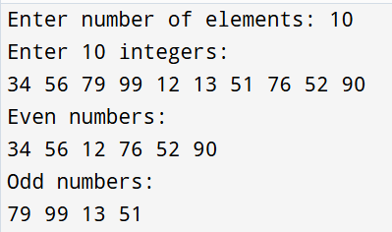
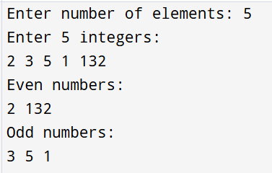

Assignment – 17:
Problem Statement:
To accept the number of terms and find the sum of the sine series.
Code:
#include <stdio.h>
int main()
{
int n, i, j;
float x, term, sum = 0;
printf("Enter value of x (in radians): ");
scanf("%f", &x);
printf("Enter number of terms: ");
scanf("%d", &n);
for(i = 1; i <= n; i++)
{
term = 1;
for(j = 1; j <= (2*i - 1); j++)
{
term = term * x;
}
for(j = 1; j <= (2*i - 1); j++)
{
term = term / j;
}
if(i % 2 == 0)
{
term = -term;
}
sum = sum + term;
}
printf("Sum of sine series = %f\n", sum);
}
Input & Output:
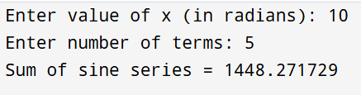
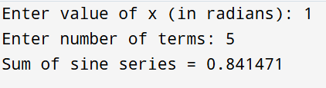

Assignment – 18:
Problem Statement:
Write a C program that accepts a string from the user and performs the following string operations: i) Calculate length of string ii) String reversal iii) Equality check of two strings iv) Check palindrome v) Check substring.
Code:
#include <stdio.h>
#include <string.h>
int main()
{
char str1[100], str2[100], temp[100];
printf("Enter a string: ");
scanf("%s", str1);
printf("Enter another string for equality check: ");
scanf("%s", str2);
printf("Length of string = %lu\n", strlen(str1));
strcpy(temp, str1);
int len = strlen(temp);
for (int i = 0; i < len / 2; i++)
{
char ch = temp[i];
temp[i] = temp[len - i - 1];
temp[len - i - 1] = ch;
}
printf("Reversed string = %s\n", temp);
if (strcmp(str1, temp) == 0)
{
printf("The string is a Palindrome\n");
}
else
{
printf("The string is not a Palindrome\n");
}
if (strcmp(str1, str2) == 0)
{
printf("Strings are equal\n");
}
else
{
printf("Strings are not equal\n");
}
if (strstr(str1, str2) != NULL)
{
printf("Substring found in main string\n");
}
else
{
printf("Substring not found in main string\n");
}
}
Input & Output:
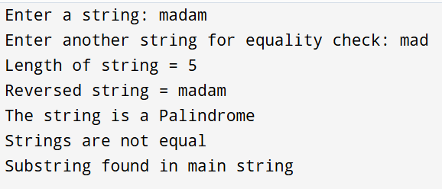
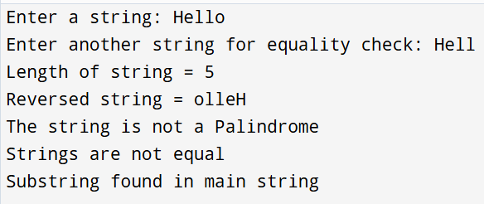

Assignment – 19:
Problem Statement:
Create Structure EMPLOYEE for storing details (Name, Designation, gender, Date of Joining and Salary). Define function members to compute a) total number of employees in an organization b) count of male and female employee c) Employee with salary more than 10,000 d) Employee with designation “Asst Manager”
Code:
#include <stdio.h>
#include <string.h>
struct EMPLOYEE
{
char name[100];
char designation[100];
char gender;
char doj[15];
int salary;
};
void gendercount(struct EMPLOYEE emp[], int n)
{
int male = 0, female = 0;
for (int i = 0; i < n; i++)
{
if (emp[i].gender == 'M')
{
male++;
}
else if (emp[i].gender == 'F')
{
female++;
}
}
printf("Male Employees = %d\n", male);
printf("Female Employees = %d\n", female);
}
void highsalary(struct EMPLOYEE emp[], int n)
{
printf("Employees with salary more than 10000: ");
for (int i = 0; i < n; i++)
{
if (emp[i].salary > 10000)
{
printf("%s ", emp[i].name);
}
}
printf("\n");
}
void asstmanager(struct EMPLOYEE emp[], int n)
{
printf("Employees with designation AsstManager: ");
for (int i = 0; i < n; i++)
{
if (strcmp(emp[i].designation, "AsstManager") == 0)
{
printf("%s ", emp[i].name);
}
}
printf("\n");
}
int main()
{
int n;
printf("Enter number of Employees: ");
scanf("%d", &n);
printf("\n");
struct EMPLOYEE emp[n];
for (int i = 0; i < n; i++)
{
printf("Enter name of Employee %d: ", i + 1);
scanf("%s", emp[i].name);
printf("Enter designation of Employee %d: ", i + 1);
scanf("%s", emp[i].designation);
printf("Enter gender (M/F) of Employee %d: ", i + 1);
scanf(" %c", &emp[i].gender); // FIXED
printf("Enter date of joining (DD-MM-YYYY) of Employee %d: ", i + 1);
scanf("%s", emp[i].doj);
printf("Enter salary of Employee %d: ", i + 1);
scanf("%d", &emp[i].salary);
printf("\n");
}
printf("Total number of employees = %d\n", n);
gendercount(emp, n);
highsalary(emp, n);
asstmanager(emp, n);
}

Input & Output:
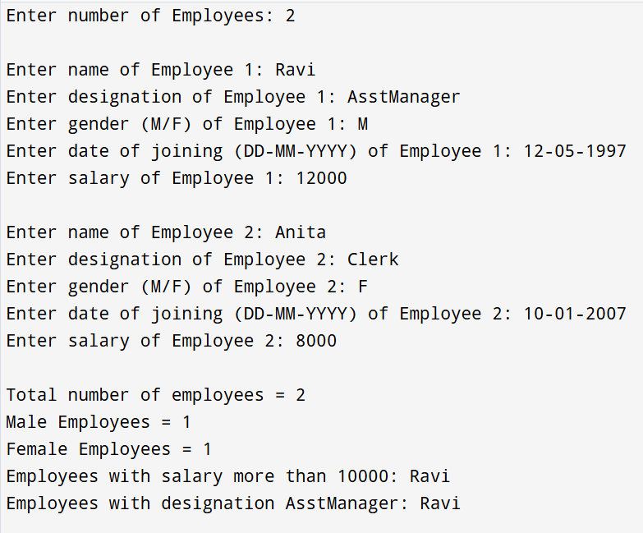

Assignment – 20:
Problem Statement:
Write a C function to swap two numbers with and without using pointers.
Code:
#include <stdio.h>
void swap_simple(int a,int b)
{
int temp;
temp=a;
a=b;
b=temp;
printf("After swapping without pointers:\n");
printf("a = %d, b = %d\n",a,b);
}
void swap_pointers(int *a,int *b)
{
int temp;
temp=*a;
*a=*b;
*b=temp;
printf("After swapping with pointers:\n");
printf("a = %d, b = %d\n",*a,*b);
}
int main()
{
int x,y;
printf("Enter numbers for swapping: ");
scanf("%d%d",&x,&y);
swap_simple(x,y);
swap_pointers(&x,&y);
}
Input & Output:
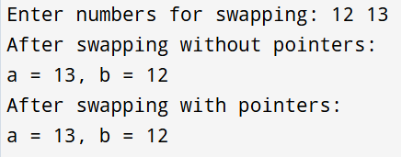
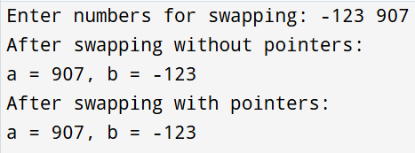

Assignment – 21:
Problem Statement:
Write a C program to copy contents of one file to another using file handling.
Code:
#include <stdio.h>
int main()
{
FILE *source,*destination;
char ch;
source=fopen("source.txt","w");
fprintf(source,"Hello World\n");
fprintf(source,"Welcome to Pune\n");
fclose(source);
source=fopen("source.txt","r");
destination=fopen("destination.txt","w");
while ((ch=fgetc(source))!=EOF)
{
fputc(ch,destination);
}
fclose(source);
fclose(destination);
printf("File copied successfully.\n");
destination=fopen("destination.txt","r");
printf("Destination file will contain:\n");
while ((ch=fgetc(destination))!=EOF)
{
putchar(ch);
}
fclose(destination);
}
Input & Output:

Assignment – 22:
Problem Statement:
Write a menu driven program in C to perform various string operations using in-built functions.
Code:
#include <stdio.h>
#include <string.h>
int main()
{
char str1[100], str2[100];
int choice;
printf("Enter first string: ");
scanf("%s", str1);
printf("Enter second string: ");
scanf("%s", str2);
printf("\n--- MENU ---\n");
printf("1. Length of string\n");
printf("2. Copy string\n");
printf("3. Compare strings\n");
printf("4. Concatenate strings\n");
printf("5. Reverse string\n");
printf("6. Substring check\n");
printf("7. Exit\n");
do
{
printf("Enter your choice: ");
scanf("%d", &choice);
switch (choice)
{
case 1:
printf("Length of first string = %lu\n", strlen(str1));
break;
case 2:
strcpy(str2, str1);
printf("After copying, second string = %s\n", str2);
break;
case 3:
if (strcmp(str1, str2) == 0)
{
printf("Strings are equal\n");
}
else
{
printf("Strings are not equal\n");
}
break;
case 4:
strcat(str1, str2);
printf("Concatenated string = %s\n", str1);
break;
case 5:
{
char temp[100];
strcpy(temp, str1);
int len = strlen(temp);
for (int i = 0; i < len / 2; i++)
{
char ch = temp[i];
temp[i] = temp[len - i - 1];
temp[len - i - 1] = ch;
}
printf("Reversed string = %s\n", temp);
break;
}
case 6:
if (strstr(str1, str2) != NULL)
{
printf("Substring found\n");
}
else
{
printf("Substring not found\n");
}
break;
case 7:
printf("Exiting program...\n");
break;
default:
printf("Invalid choice\n");
}
} while (choice != 7);
}

Input & Output:
